CUSTOMER BEHAVIOR ANALYSIS
Interactive Data Analytics & Business Intelligence Project
Prepared By
Aditya Khanna

Bachelor of Computer Applications (BCA)
Institute of Technology and Science (ITS), Ghaziabad

TOOLS & TECHNOLOGIES
Python | Pandas | PostgreSQL | SQL | Power BI

PROJECT REPORT
2026

01 PROJECT INTRODUCTION
  - Project Overview
Customer Behavior Analysis is a data analytics and business intelligence project designed to understand customer purchasing patterns and shopping behavior through transactional data. The project brings together customer demographics, purchase information, subscription status, previous purchasing behavior, product ratings, shipping preferences, and other shopping-related attributes to identify meaningful patterns and trends.
The analysis focuses on understanding how different customer groups contribute to sales and revenue, which product categories perform strongly, how subscription and repeat-purchase behavior varies, and which products receive higher customer ratings. The final insights are presented through an interactive Power BI dashboard that enables users to explore the data using filters and dynamically updated analytical insights.
  - Problem Statement
Customer transaction data contains valuable information about purchasing behavior, but raw data alone does not provide an efficient way to identify important business patterns. Without proper analysis, it can be difficult to determine which categories generate the most revenue, which customer groups contribute significantly to sales, how subscription status relates to customer behavior, and how repeat purchasing patterns influence overall performance.
Therefore, the objective of this project is to transform raw customer shopping data into meaningful and easy-to-understand business insights using data preparation, SQL-based analysis, and interactive Power BI visualizations. The dashboard provides a centralized view of key performance indicators, customer segments, purchasing patterns, and product performance to support data-driven decision-making.
  - Project Objectives
- Analyze customer purchasing behavior to identify meaningful spending and shopping patterns.
- Evaluate category performance by comparing sales and revenue across different product categories.
- Understand customer demographics by analyzing sales and revenue across different age groups and genders.
- Analyze subscription and repeat-buyer behavior to understand customer engagement and retention patterns.
- Evaluate product performance using customer review ratings and purchasing activity.
Develop an interactive Power BI dashboard with slicers, KPIs, visualizations, dynamic insights, and a reset-filter feature for efficient data exploration.
02 DATASET OVERVIEW
2.1 Dataset Summary

The dataset used for this project contains 3,900 customer purchase records and 18 columns. It captures a wide range of information related to customer demographics, product preferences, purchasing activity, subscription status, shipping preferences, payment methods, and customer feedback. The dataset provides a comprehensive foundation for analyzing shopping behavior, identifying purchasing patterns, and understanding customer engagement.

The data includes both categorical and numerical variables, allowing the analysis to examine customer segments, sales and revenue patterns, product performance, subscription behavior, repeat purchases, and review ratings through SQL analysis and interactive Power BI visualizations.

2.2 Dataset Characteristics

Attribute | Description
Records | 3,900 customer purchase records
Columns | 18 variables
Customer Demographics | Age, Gender, and Location
Product Information | Item Purchased, Category, Size, Color, and Season
Purchase Information | Purchase Amount (USD)
Customer Behavior | Previous Purchases and Frequency of Purchases
Customer Feedback | Review Rating
Subscription | Subscription Status
Delivery | Shipping Type

2.3 Key Variables

- Customer Demographics: Age, Gender, Location, Subscription Status
- Product & Purchase Details: Item Purchased, Category, Purchase Amount, Size, Color, Season
- Customer Behavior: Previous Purchases, Frequency of Purchases, Discount Applied
- Subscription & Customer Experience: Review Rating, Shipping Type, Payment Method
03 DATA CLEANING USING PYTHON & PANDAS
3.1 Data Loading
The customer shopping behavior dataset was loaded into Python using the Pandas library. The dataset contains 3,900 customer purchase records and 18 columns covering customer demographics, product information, purchase details, shopping behavior, subscription status, shipping preferences, payment methods, and review ratings. Pandas was used to inspect, clean, transform, and prepare the dataset for further analysis. Figure 1: Initial Dataset Preview using Pandas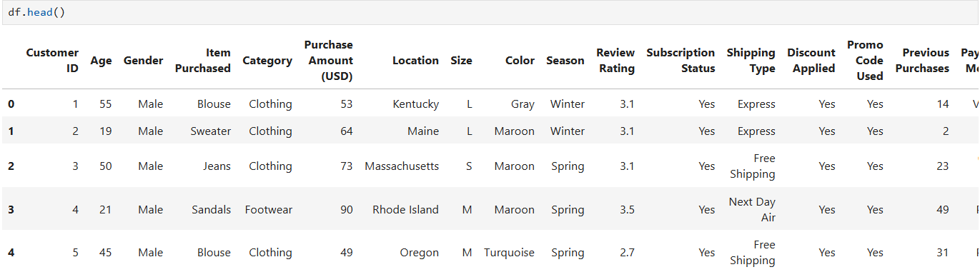
Figure 1: Initial Dataset Preview using Pandas
3.2 Initial Data Exploration
After loading the dataset, an initial exploration was performed to understand its structure, data types, and completeness. The df.info() function was used to examine the number of records, columns, non-null values, and data types present in the dataset. The output confirmed 3,900 entries across 18 columns. Most columns contained complete records, while the Review Rating column contained 3,863 non-null values.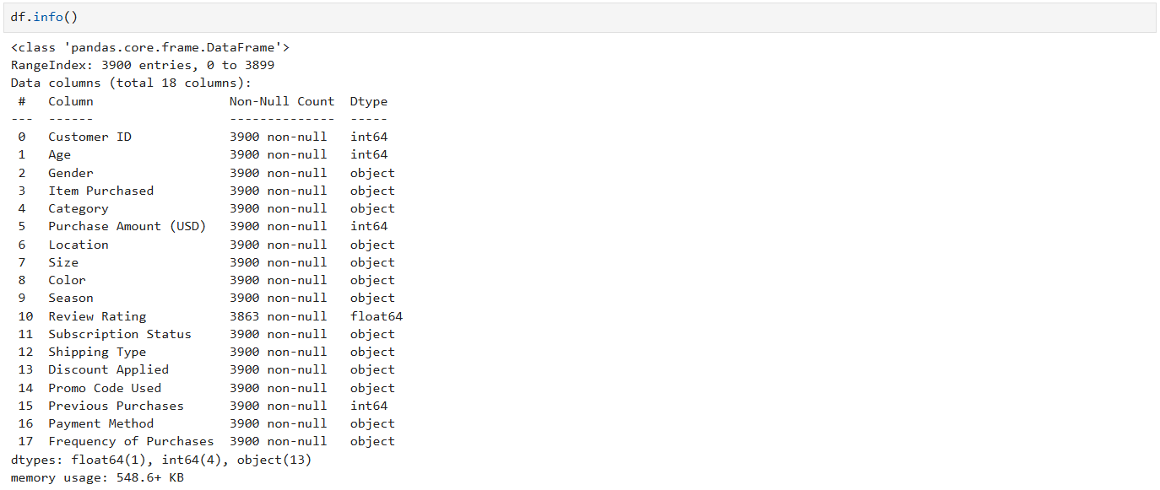
Figure 2: Dataset Structure and Data Types

3.3 Missing Value Assessment
Missing values were examined before performing further data preparation. The df.isnull().sum() function was used to identify incomplete values across all columns. The assessment identified 37 missing values in the Review Rating column, while all other columns contained no missing values.
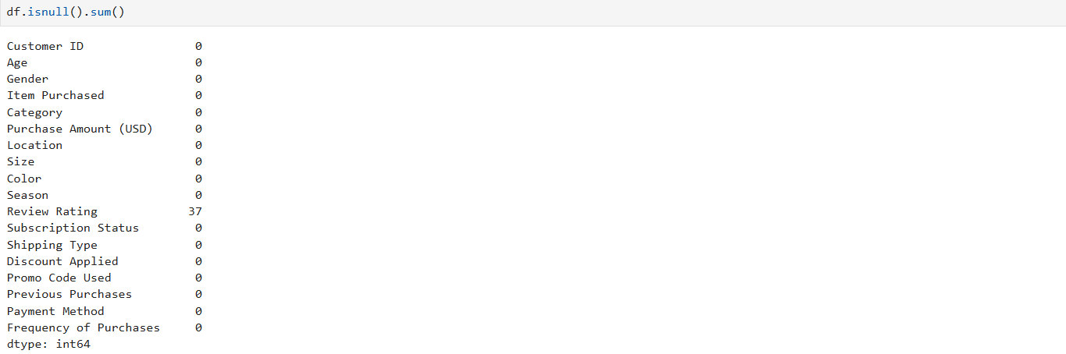
Figure 3: Missing Value Assessment Before Cleaning

3.4 Missing Value Treatment
The missing Review Rating values were handled using category-level median imputation. The median rating was calculated separately for each product category and used to replace the missing values. This approach preserved the available records while providing a category-specific value for the missing ratings.
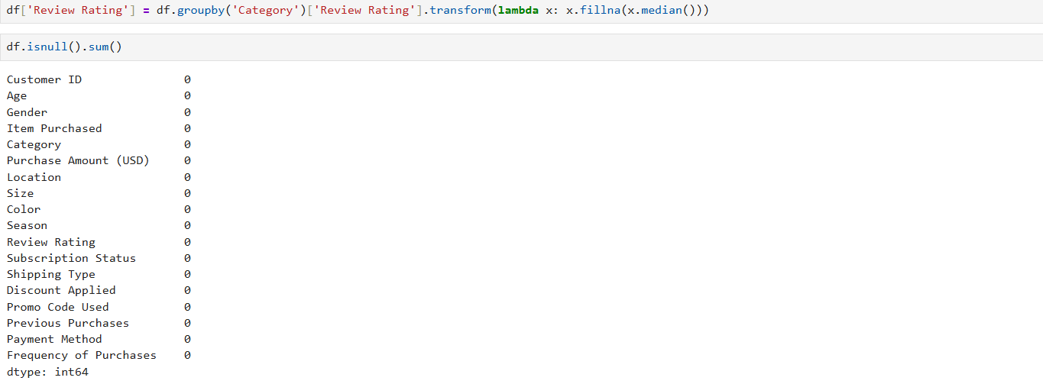
Figure 4: Review Rating Imputation and Post-Cleaning Null Check

3.5 Data Standardization
The dataset was standardized to improve consistency and make the data easier to use during analysis. Column names were converted into a consistent snake_case format for easier referencing in Python and SQL queries.
The data was also reviewed for redundant information. The Promo Code Used column was removed because it provided redundant information alongside the Discount Applied field.
3.6 Feature Engineering
Additional features were created to support customer behavior analysis. An Age column was added as part of the data preparation process, and a Frequency Mapping column was created to convert purchase-frequency categories into a more analysis-friendly representation.
These engineered features provided additional dimensions for customer segmentation and behavioral analysis and were subsequently used during the SQL and Power BI stages.
3.7 Final Dataset Preparation
After completing the cleaning, standardization, and feature engineering steps, the prepared dataset was ready for the next stage of analysis. The cleaned DataFrame was subsequently prepared for integration with PostgreSQL and further SQL-based business analysis.
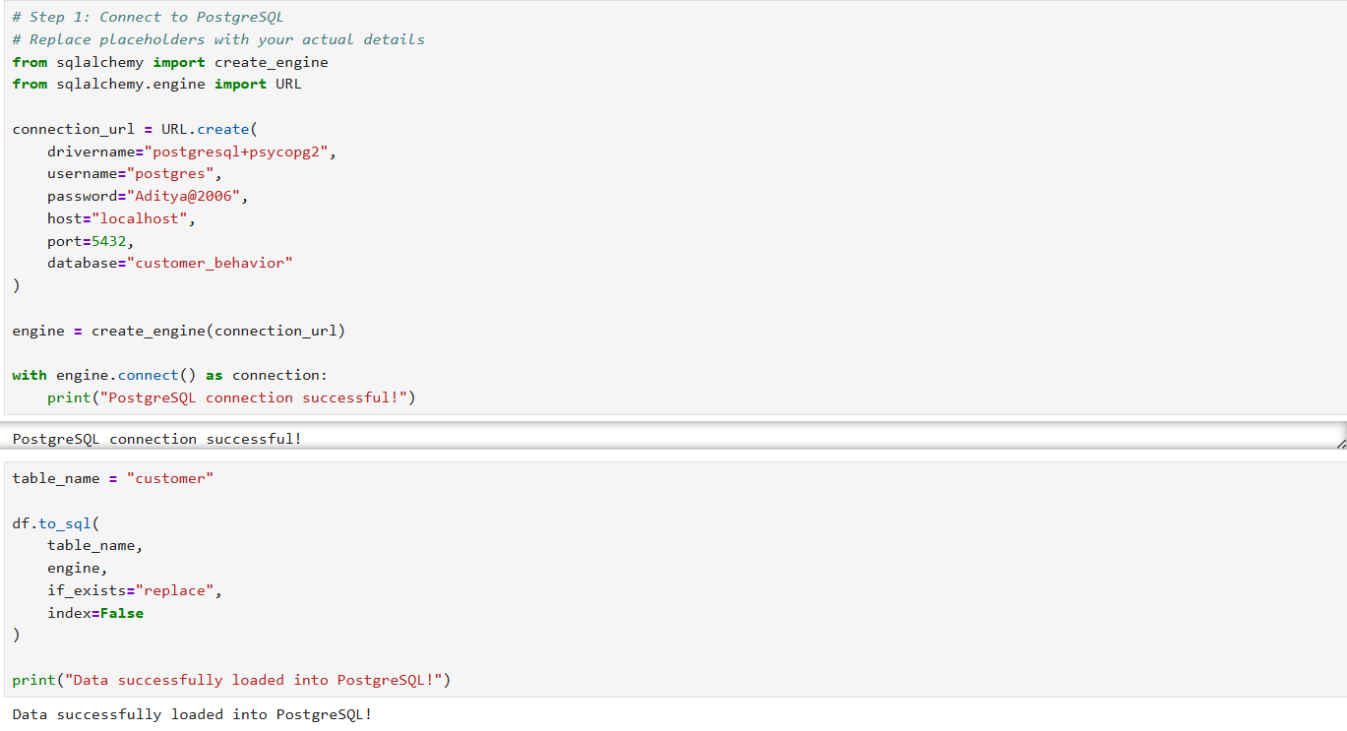
Figure 5: Cleaned Dataset Loaded into PostgreSQL

Python & Pandas Cleaning → Feature Engineering → PostgreSQL Database → SQL Analysis
04 SQL ANALYSIS
4.1 Database Integration
After completing the data cleaning and feature engineering process in Python and Pandas, the prepared dataset was connected to PostgreSQL for structured storage and SQL-based analysis. The cleaned customer data was loaded into the customer table within the customer_behavior database.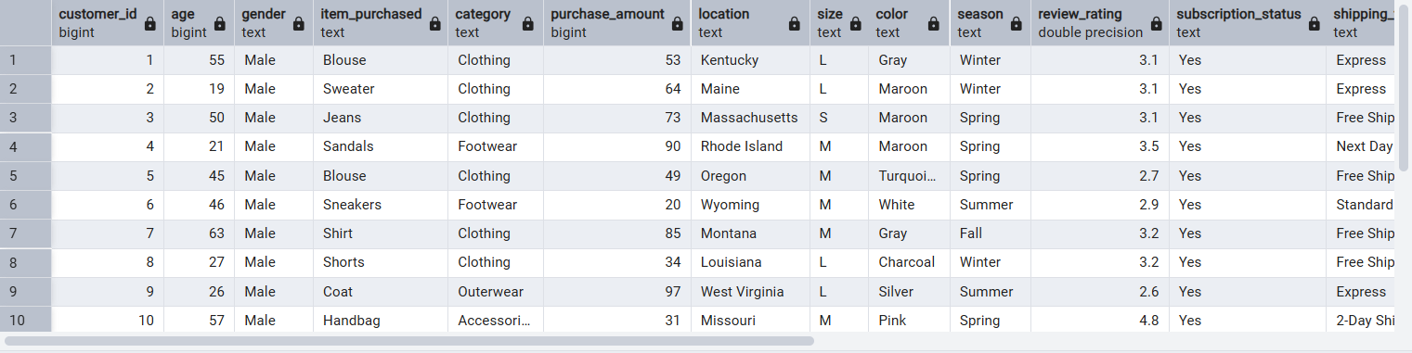
Figure 6: Customer Data Loaded into PostgreSQL
4.2 SQL-Based Business Analysis
SQL was used to transform the cleaned customer data into meaningful business information. A set of ten business questions was developed to analyze customer spending, revenue, product performance, subscription behavior, discounts, customer loyalty, repeat purchases, and age-group contribution.
The following analyses were selected to highlight the most relevant business findings from the project.
4.3 Revenue Analysis
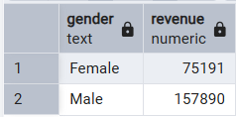
Q1. What is the total revenue generated by male vs. female customers?
Ans. The analysis compares the total purchase revenue generated by male and female customers. This helps understand the revenue contribution of different customer groups.

Figure 7: Revenue Comparison by Gender
Q2. Which customers used a discount but still spent more than the average purchase amount?
Ans. This analysis identifies customers who used a discount but still made purchases equal to or above the overall average purchase amount. It helps identify relatively high-value customers who purchased using discounts.
Q3. Which are the top 5 products with the highest average review rating?
Ans. The average review rating was calculated for each product and the five products with the highest average ratings were identified. This provides an overview of products receiving the strongest customer feedback.
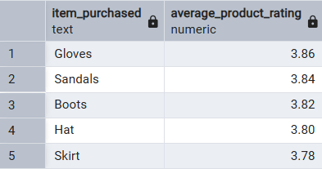
Figure 8: Top 5 Products by Average Review Rating
Q4. Compare the average Purchase Amounts between Standard and Express Shipping.
Ans. The analysis compares the average purchase amount between Standard and Express shipping customers to identify differences in spending based on shipping preference.
Q5. Do subscribed customers spend more?
Ans. Subscribers and non-subscribers were compared using customer count, average purchase amount, and total revenue. This helps evaluate whether subscription status is associated with higher customer spending.
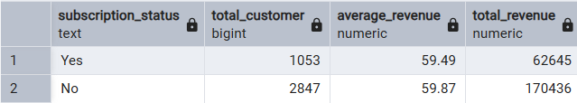
Figure 9: Spending Comparison by Subscription Status
4.5 Product & Customer Behavior Analysis
Q6. Which 5 products have the highest percentage of purchases with discounts applied?
Ans. The discount rate was calculated for each product based on the percentage of purchases where a discount was applied. The analysis identifies products with the highest proportion of discounted purchases.
Q7. Segment customers into New, Returning, and Loyal based on their total number of previous purchases.
Ans. Customers were classified into three segments according to their previous purchase history:
• New — customers with 1 previous purchase
• Returning — customers with 2 to 10 previous purchases
• Loyal — customers with more than 10 previous purchases
The analysis measures the size of each customer segment and provides an indication of customer loyalty.
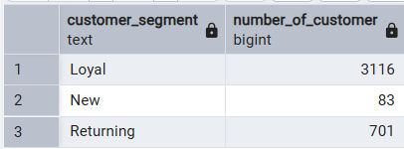
Figure 10: Customer Segmentation Based on Previous Purchases
4.6 Product Ranking by Category
Q8. What are the top 3 most purchased products within each category?
Ans. Products were ranked within each category according to their total number of orders. The analysis identifies the three most purchased products in each category and provides a category-level view of product popularity.
4.7 Repeat Buyer & Subscription Analysis
Q9. Are customers who are repeat buyers, with more than 5 previous purchases, also likely to subscribe?
Ans. Repeat buyers were identified using a threshold of more than five previous purchases. Their subscription status was then compared to determine the distribution between subscribed and non-subscribed repeat buyers.
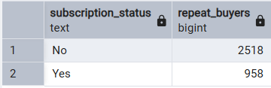
Figure 11: Repeat Buyers by Subscription Status
4.8 Revenue Contribution by Age Group
Q10. What is the revenue contribution of each age group?
Ans. Total purchase revenue was aggregated for each age group and ranked from highest to lowest. This analysis highlights the age groups contributing the most revenue to the business.
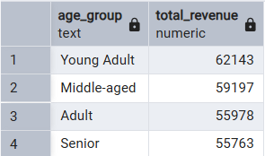
Figure 12: Revenue Contribution by Age Group
4.9 SQL Analysis Summary
The SQL analysis provided a structured view of customer behavior and business performance. The analysis covered revenue distribution, customer spending, product ratings, subscription behavior, discount usage, customer segmentation, product popularity, repeat purchasing, and age-group revenue contribution.
The SQL results formed the analytical foundation for the Power BI dashboard, where the findings were transformed into interactive visualizations, filters, KPIs, and dynamic insights.
SQL Analysis Completed → Business Insights Identified → Power BI Dashboard
05 POWER BI DASHBOARD
5.1 Dashboard Development
After completing the data cleaning, feature engineering, and SQL analysis stages, the prepared customer data was used to develop an interactive dashboard in Microsoft Power BI.
The dashboard was designed to provide a clear and interactive view of customer purchasing behavior, revenue performance, subscription patterns, repeat buyers, product ratings, and age-group contribution. Interactive filters and dynamic insights were incorporated to allow users to explore the data from different perspectives.
5.2 Dashboard Objectives
The primary objectives of the dashboard were:
• Monitor key customer and revenue metrics through KPI cards.
• Analyze customer subscription and repeat-purchase behavior.
• Identify highly rated products and revenue-generating age groups.
• Provide interactive filtering for customer-level analysis.
• Present dynamic business insights based on selected filters.

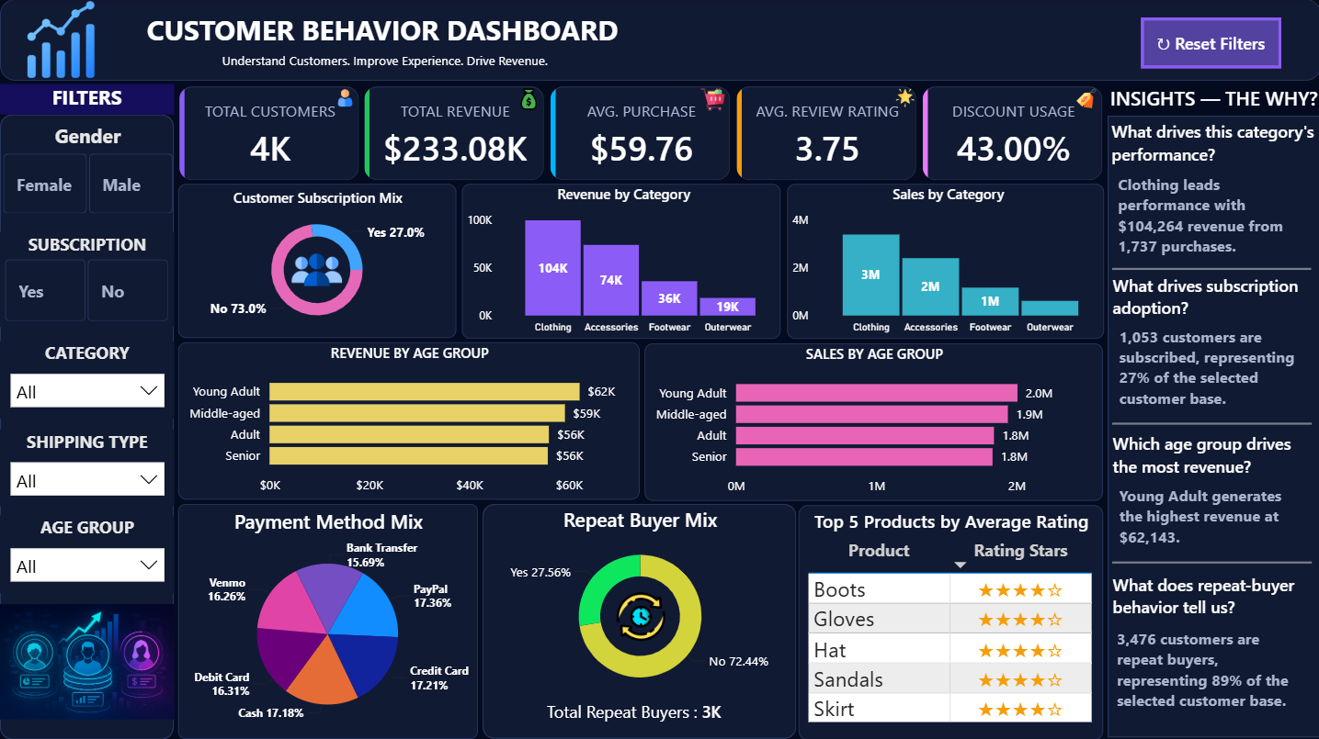

Figure 13: Customer Shopping Behavior Analysis Dashboard

5.3 Dashboard Components
The dashboard combines KPI cards, charts, slicers, and dynamic insight sections to present the analysis in a compact and interactive format.
Key dashboard components include:
• Total Customers — Displays the overall number of customers in the dataset.
• Total Revenue — Shows the overall purchase revenue generated.
• Average Purchase — Represents the average purchase amount.
• Average Rating — Displays the overall average customer rating.
• Customer Subscription Mix — Compares subscribed and non-subscribed customers.
• Revenue by Age Group — Shows the contribution of different age groups to total revenue.
• Top 5 Products by Average Rating — Highlights products with the highest average customer ratings.
• Repeat Buyers by Subscription — Shows the subscription distribution among customers with more than five previous purchases.
• Interactive Filters — Allow users to analyze the dashboard according to selected customer attributes.
5.4 Interactive Features
The dashboard includes interactive slicers and filters that allow users to dynamically explore customer behavior. The visualizations and insight statements respond to the selected filters, making it possible to analyze specific customer segments without changing the underlying report.
A Reset Filters button was also incorporated to quickly return the dashboard to its default view after applying multiple filters.
Power BI Dashboard → Interactive Analysis → Dynamic Business Insights
5.5 KPI Analysis
The dashboard begins with a set of key performance indicators that provide a quick overview of customer activity and purchasing performance. These KPIs help users understand the overall scale and performance of the customer dataset before exploring individual visualizations.
Total Customers
This KPI displays the total number of customers included in the analysis and provides an overview of the customer base.
Total Revenue
This KPI represents the total purchase revenue generated across all customer transactions and provides a high-level view of overall revenue performance.
Average Purchase
This KPI shows the average amount spent per purchase, helping to understand the typical transaction value of customers.
Average Rating
This KPI represents the average customer review rating and provides an overall indication of customer satisfaction with purchased products.
5.6 Customer Behavior Analysis
Customer Subscription Mix
The subscription visual compares subscribed and non-subscribed customers. It provides a clear view of the distribution of customers according to their subscription status and helps understand the overall subscription penetration.
Repeat Buyers by Subscription
This visual focuses on customers with more than five previous purchases and compares their subscription status. It helps determine whether repeat purchasing behavior is associated with customer subscription.
The dashboard also displays the total number of repeat buyers, providing a quick reference for the size of this customer group.
5.7 Product Performance Analysis
Top 5 Products by Average Rating
This visual highlights the five products with the highest average customer review ratings. It helps identify products that received stronger customer feedback and can be useful for understanding product satisfaction.
Revenue by Age Group
The revenue-by-age-group visual compares the total revenue generated by different customer age groups. It helps identify which age segments contribute the most to overall purchase revenue.
5.8 Interactive Filtering
Interactive filters allow users to explore the dashboard according to selected customer attributes. When a filter is applied, the KPIs, charts, and dynamic insight statements update according to the selected data.
This interactive functionality enables users to move from an overall business view to a more focused analysis of specific customer groups and purchasing patterns.
A Reset Filters button was also added to restore the dashboard to its default state after applying multiple filters.
5.9 Dynamic Insights
The dashboard includes a dedicated Insights section that presents business questions followed by dynamically changing answers. These insights respond to the selected filters, allowing users to understand the reasons behind changes in the displayed metrics.
The dynamic insight approach makes the dashboard more analytical by moving beyond static charts and helping users interpret the results based on the selected customer segment.
Dashboard Visuals → Interactive Filters → Dynamic Insights → Business Understanding

06 KEY BUSINESS INSIGHTS
6.1 Overall Business Performance
The dashboard contains approximately 4K customers and generates total revenue of $233.08K. The average purchase amount is $59.76, while the overall average customer rating stands at 3.75.
These KPIs provide a high-level view of the customer base, revenue performance, purchasing behavior, and overall product satisfaction.
6.2 Customer Subscription Behavior
The customer base consists of 27% subscribers and 73% non-subscribers. This indicates that the majority of customers are currently not subscribed.
The relatively lower subscription penetration highlights an opportunity to improve subscription adoption through targeted benefits, personalized offers, and loyalty-focused strategies.
6.3 Repeat Buyer Behavior
The dashboard identifies approximately 3K repeat buyers, making repeat customers a significant part of the overall customer base.
The presence of a large repeat-buyer segment indicates strong recurring purchasing activity and creates an opportunity for the business to strengthen customer retention and loyalty programs.
6.4 Revenue Contribution by Age Group
The Young-Adult age group is the top-performing age segment in terms of revenue contribution.
This indicates that Young-Adult customers represent an important customer segment and could be given greater attention through targeted marketing campaigns, relevant product recommendations, and personalized promotional strategies.
6.5 Product Performance
Boots is identified as the highest-rated product based on average customer review ratings.
The strong rating suggests positive customer feedback for the product. Such high-performing products can be highlighted in promotional campaigns and product recommendation strategies.
6.6 Customer Satisfaction
The overall average rating of 3.75 indicates a generally positive level of customer feedback across the analyzed products.
However, the rating also leaves room for improvement. The business can use product-level ratings to identify weaker-performing products and investigate the factors affecting customer satisfaction.
6.7 Key Takeaway
The analysis shows a customer base of approximately 4K, generating $233.08K in revenue with an average purchase of $59.76. Around 3K customers are repeat buyers, while only 27% of customers are subscribed.
Young-Adult customers are the leading revenue-contributing age group, and Boots has the highest average rating among the analyzed products.
Together, these findings highlight opportunities to strengthen customer retention, increase subscription adoption, focus on high-performing customer segments, and improve product-level performance.
07 BUSINESS RECOMMENDATIONS
7.1 Increase Subscription Adoption
Only 27% of customers are currently subscribed, while 73% are non-subscribers. This indicates a significant opportunity to increase subscription adoption.
The business can introduce stronger subscription benefits such as exclusive discounts, free or faster shipping, loyalty rewards, early access to products, and personalized offers. Targeting frequent purchasers with these benefits can help convert more non-subscribers into subscribers.
7.2 Strengthen Repeat Customer Retention
Approximately 3K customers are identified as repeat buyers, making customer retention an important area of focus.
The business should develop loyalty programs and personalized retention campaigns for repeat customers. Personalized product recommendations, milestone rewards, and targeted offers can encourage repeat buyers to continue purchasing.
7.3 Target the Young-Adult Segment
The Young-Adult segment is the top-performing age group in terms of revenue contribution.
Marketing campaigns should therefore pay particular attention to this segment. Personalized promotions, relevant product recommendations, digital campaigns, and targeted offers can be used to strengthen engagement with Young-Adult customers.
7.4 Promote High-Rated Products
Boots is identified as the highest-rated product based on customer reviews.
The business can use highly rated products such as Boots in promotional campaigns, recommendation sections, and cross-selling strategies. Positive customer feedback can also be used as social proof to support product promotion.
7.5 Improve Customer Satisfaction
The overall average customer rating is 3.75. Although the rating indicates a generally positive customer experience, there is still scope for improvement.
The business should monitor product-level ratings, identify products receiving weaker feedback, and investigate issues related to product quality, delivery, pricing, or customer experience.
7.6 Increase Average Purchase Value
The average purchase amount is $59.76. The business can focus on increasing average transaction value through product bundling, cross-selling, personalized recommendations, and threshold-based offers.
For example, customers can be encouraged to add complementary products to their purchases through relevant recommendations or offers based on their previous buying behavior.
7.7 Adopt Data-Driven Decision Making
The project demonstrates the value of combining Python, PostgreSQL, SQL, and Power BI into a single analytical workflow.
The business should continue monitoring customer behavior through interactive dashboards and regularly evaluate changes in revenue, subscriptions, repeat purchases, product ratings, and customer segments to support informed decision-making.
08 CONCLUSION & FUTURE SCOPE
8.1 Conclusion
The Customer Shopping Behavior Analysis project demonstrates an end-to-end data analytics workflow for converting raw customer data into meaningful business insights.
The project began with Python and Pandas, where the dataset was inspected, cleaned, standardized, and transformed. Missing Review Rating values were handled using category-level median imputation, while additional features such as Age and Frequency Mapping were created to support customer behavior analysis.
The prepared dataset was then integrated with PostgreSQL, providing a structured environment for storing and analyzing the cleaned customer data. SQL was used to answer ten business questions covering revenue, customer spending, product ratings, shipping behavior, subscription patterns, discount usage, customer segmentation, product popularity, repeat buyers, and age-group revenue contribution.
The final stage involved developing an interactive Power BI dashboard. The dashboard combines KPI cards, customer behavior visuals, product analysis, age-group revenue analysis, interactive filters, dynamic insights, and a Reset Filters button.
The final analysis identified approximately 4K customers, $233.08K in total revenue, an average purchase of $59.76, and an average rating of 3.75. Approximately 3K customers are repeat buyers, while 27% of customers are subscribed. The Young-Adult segment is the top-performing age group, while Boots is the highest-rated product.
Overall, the project demonstrates how data cleaning, database management, SQL analysis, visualization, and business interpretation can be combined to create a practical data-driven decision-support solution.
8.2 Future Scope
The project can be further enhanced by introducing advanced analytical and predictive capabilities.
• Customer Lifetime Value analysis can be implemented to identify customers with the highest long-term business value.
• Customer churn prediction can be developed to identify customers who may become inactive and require targeted retention strategies.
• Advanced customer segmentation can be performed using purchasing frequency, spending behavior, subscription status, and customer engagement.
• Time-based analysis can be introduced when sufficient historical transaction dates are available to identify seasonal purchasing patterns and revenue trends.
• Automated data refresh can be implemented to keep the Power BI dashboard updated with the latest customer information.
• Predictive product recommendation systems can be explored to suggest relevant products based on individual customer purchasing behavior.
8.3 Skills & Technologies Applied
The project provided practical experience in:
• Python and Pandas — Data cleaning, transformation, and feature engineering
• PostgreSQL — Database connection, storage, and data management
• SQL — Business analysis, aggregation, segmentation, ranking, and analytical queries
• Power BI — Interactive dashboards, KPIs, filters, and dynamic insights
• Data Analysis — Identifying patterns, interpreting results, and converting analytical findings into business recommendations
8.4 Final Project Workflow
Raw Customer Data
↓
Python & Pandas Data Cleaning
↓
Feature Engineering
↓
PostgreSQL Database
↓
SQL Business Analysis
↓
Power BI Dashboard
↓
Business Insights
↓
Recommendations & Decision Making
PROJECT COMPLETED

